Alfred Acosta

1/27/17

Database Management

Lab 2

1. Screenshots  
     
   Customers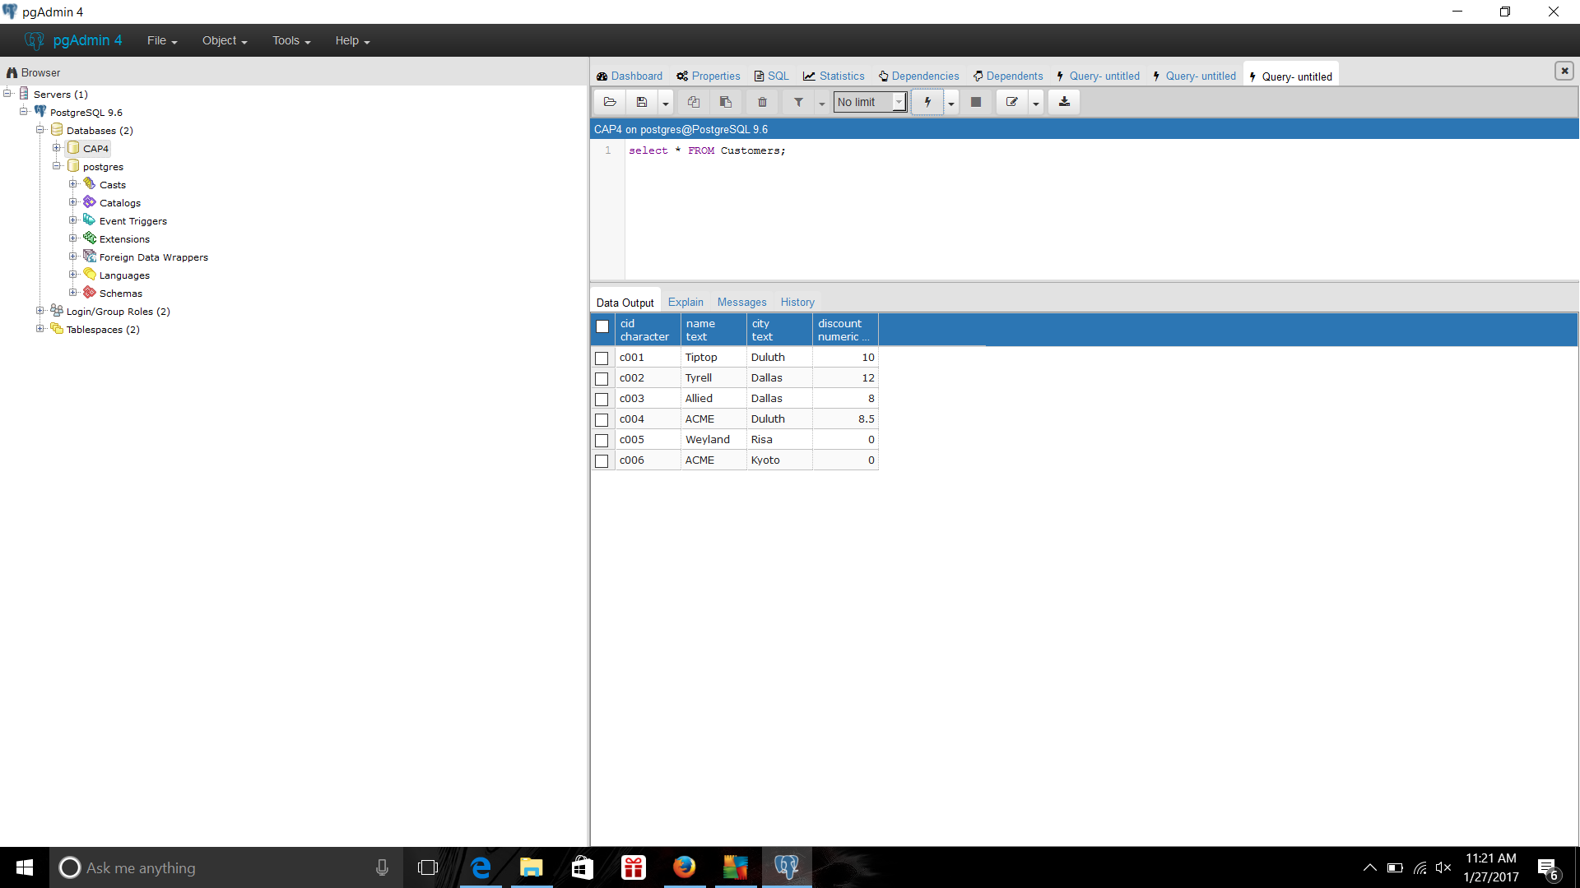Agents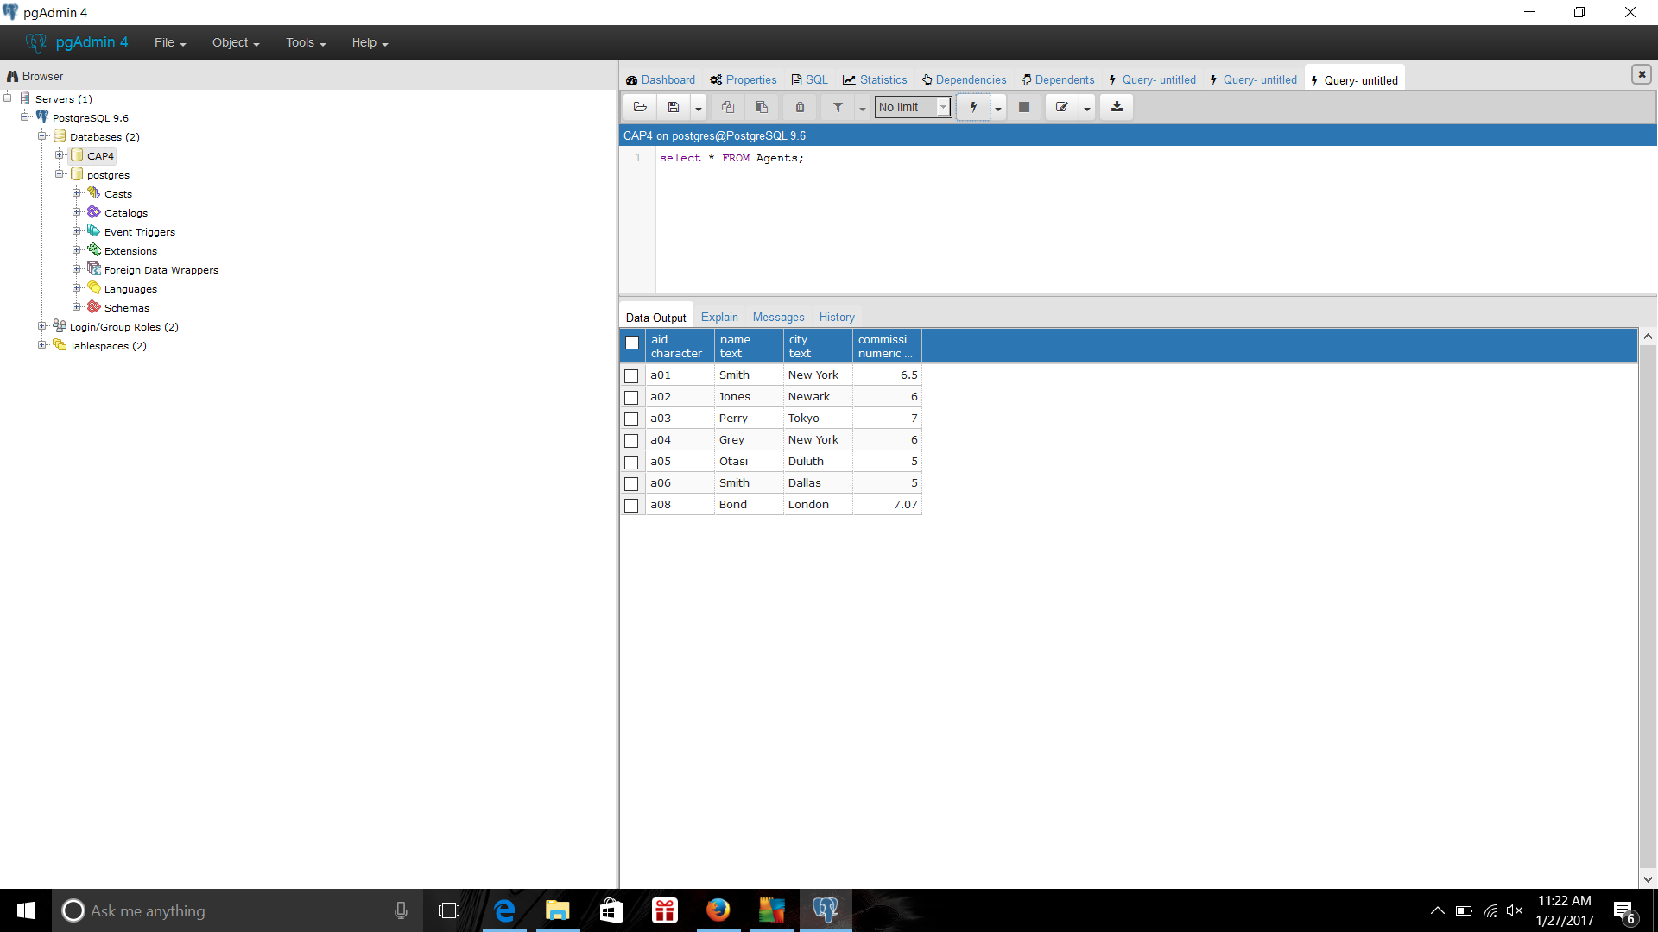

Products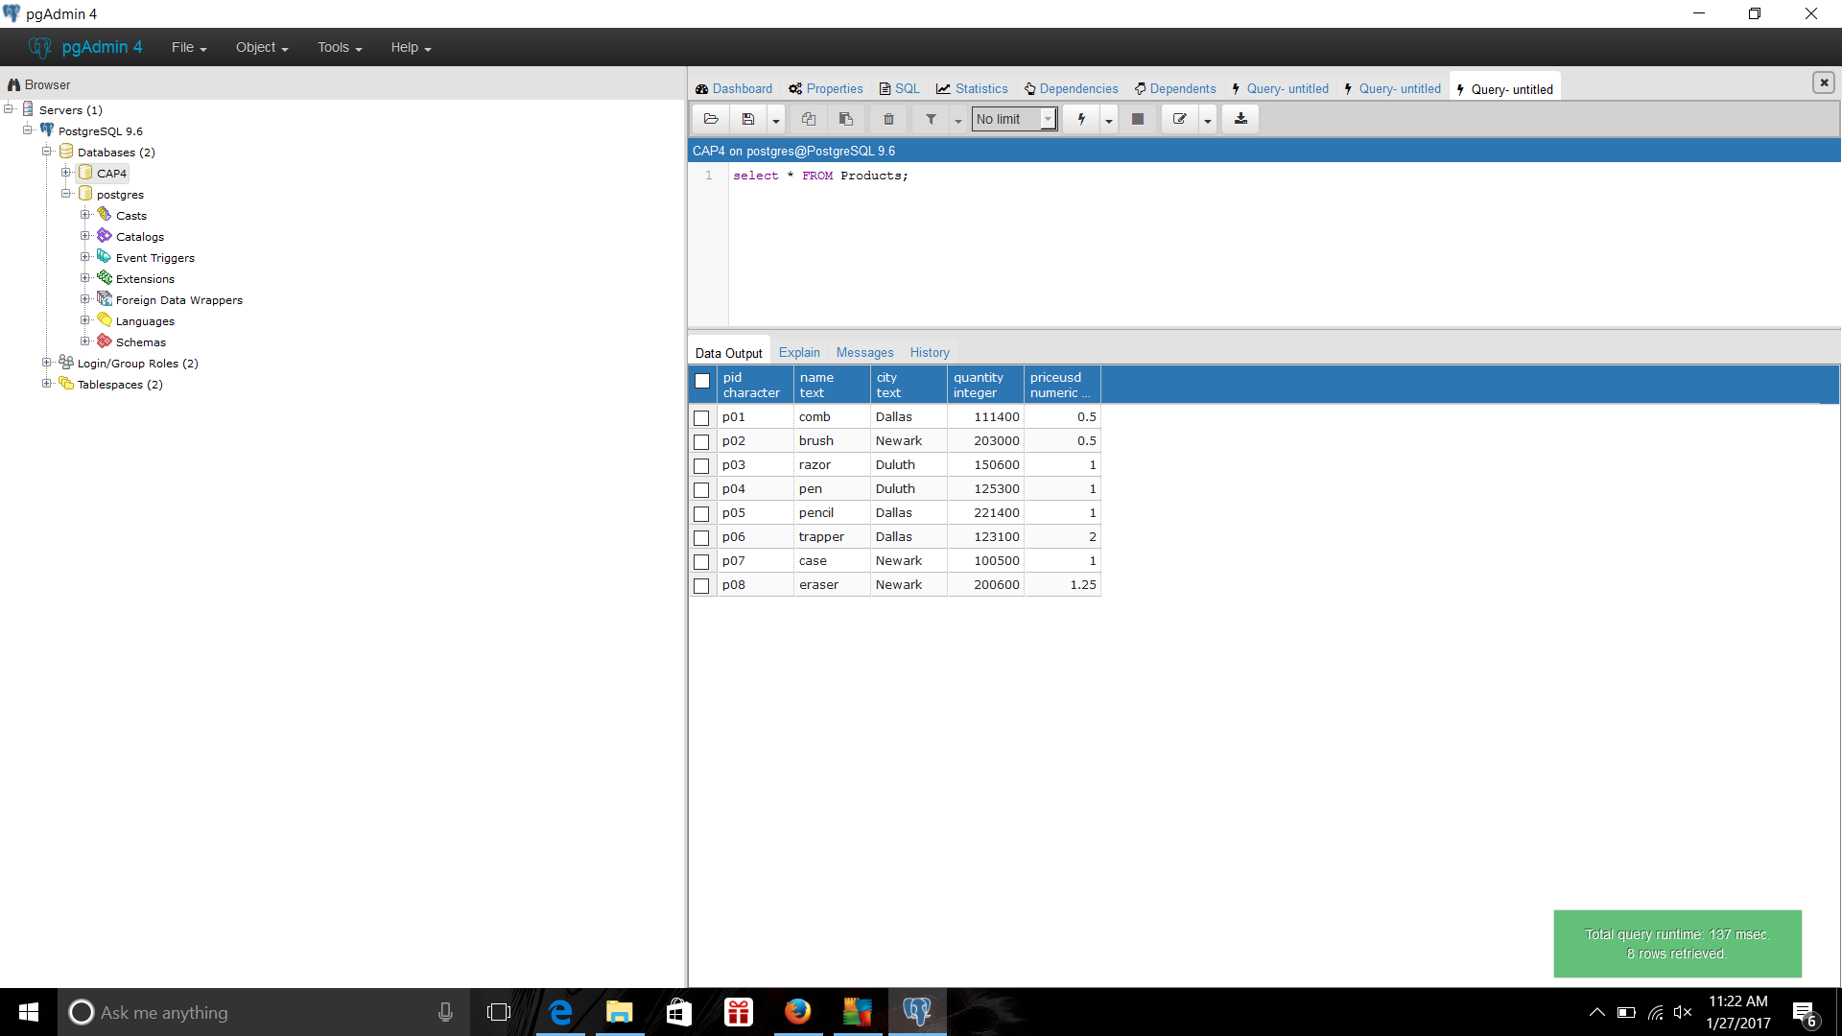Orders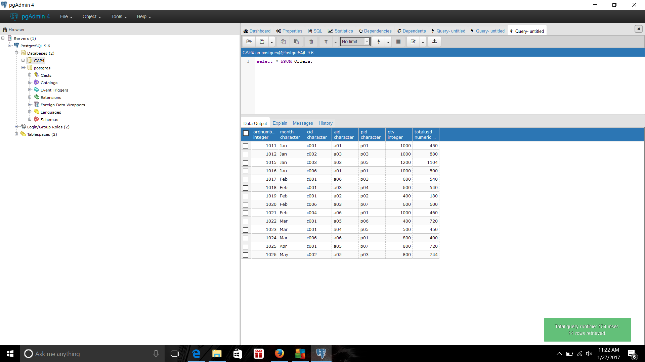

1. Primary key-The chosen candidate key (each table can only have one primary key).  
   Candidate key – super key with minimal number of columns.

Super Key – Column or set of columns that ensures that every row will be unique.

1. Data types are used to specify the attributes for our tables. For example, we use INT or FLOAT for whole numbers and decimals respectively for our columns. We use VARCHAR if we want characters for names as it will translate the characters to hexadecimal so it can match it. And Boolean is used for logic true or false. For example, say that I want to create a table for a hotel reservation, and for that I need a table for reservations in the database and I need to have a column for the name of the building, the id for it, and the number of available and occupied rooms. For each column, I would specify the data type for each column attribute. For the ID column, I would make it the primary key and set it as INT auto-increment type. For the name column, I would set it as VARCHAR since the buildings each have different names. And for the Available and occupied columns, I would set it as INT type since it is whole numbers and cannot be decimals so FLOAT or DOUBLE data types will make no difference. And of course, all the columns are not nullable since they are necessary to make the table work properly.

|  |  |  |  |
| --- | --- | --- | --- |
| ID (INT, Not Nullable) | Name (VARCHAR, Non-Nullable | Available (INT, Not Nullable | Occupied (INT, Not Nullable) |
| 1 | Hancock | 5 | 0 |
| 2 | Lowell | 3 | 2 |
| 3 | Farside | 1 | 4 |

1. First normal form – The definition of this rule is that the domain of each attribute must contains only atomic values, and the value of each attribute contains only a single value from that domain. This helps reduce inconsistency in the database and it makes the user only input that specific type of data. For example, in the table above the Available column only has numbers. And the Name column only has characters.

Access rows by content only – The meaning of the rule is that we should access the content by name instead of labels. This helps prevent inconsistencies if we are accessing the table and it gets modified. For example, on the table above if we wanted to access column 1 and 3, it would return the ID and Available column. But, if we add a column between the Name and Available column, and we access columns 1 and 3, it would return the ID and that newly created column instead.

All rows must be unique – The meaning of the rule is that each column should have a unique name to prevent inconsistencies for when you are looking for data and when you access it. For example, in the table above if I have the Available and Occupied columns named Room, it would make it hard for the user to access the data since it has the same name and the database will get confused.